GAS TURBINE
POWER ENGINEERING
Steam power plant | Gas Turbine | IC engine | Hydro Power Plant | Renewable Energy Plant
- Rankine: weight and power production is high.  - Brayton/ Joule’s Cycle: Used for Air Craft Refrigeration. |  |  | - SI Engine & CI Engine: Used in automobiles.  - Tidal, Wind, Solar are examples of the renewable sources.

THERMODYNAMIC CYCLES
POWER CYCLE |  | REFRIGERATION CYCLE
VAPOUR CYCLE | GAS CYCLE | VAPOUR CYCLE | GAS CYCLE
Rankine Cycle, etc… | Otto, Diesel, Atkinson, etc… | VAR, VCR, etc… | Bell Coalmen Cycle
- VAPOUR CYCLE: Working fluid changes it’s phase during the cycle.
- GAS CYCLE: Working fluid remains in same phase throughout the cycle.
ASSUMPTION OF AIR STANDARD CYCLE:
- Air is the working fluid throughout the cycle.
- $C_{P}$ & $C_{V}$ values are constant with respect to temperature.
- System is considered as closed undergoing the cyclic process.
- Suction and discharge are not considered.
- Combustion is replaced by equivalent amount of heat addition process. E.g. Combustion phenomena is chemical reaction which is not justifying Thermodynamic equilibrium condition.
- Exhaust is replaced by equivalent amount of heat Rejection process.
- Compression and expansion are considered to be reversible adiabatic processes but actual process is irreversible.
Reversible Processes are Very Slow process. | Adiabatic Processes are Very Fast process.

Brayton Cycle: Centrifugal Components are used. | Joule’s Cycle: Reciprocating component are used.
SIMPLE/ OPEN BRAYTON CYCLE:
1-2: Rev. Adiabatic (Isentropic) Compression | 2-3: Constant pressure Heat Addition.
3-4: Rev. Adiabatic (Isentropic) Expansion | 4-1: Constant pressure heat Rejection.

$${\dot{Q}}_{in}={\dot{m}}_{f} \left(CV\right)$$ | $$W_{net}=W_{T}-W_{C}$$

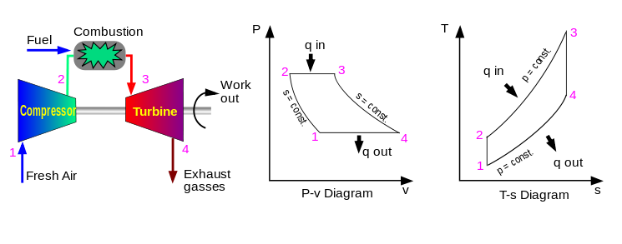 | 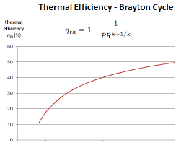  $$η Vs. r_{P} for constant γ$$
EFFICIENCY OF SIMPLE/ OPEN BRAYTON CYCLE:
2-3: Form 1st law of TD and For Ideal Gas $dh=C_{P}dT$  $$q_{in}=h_{3}-h_{2}=C_{P}\left(T_{3}-T_{2}\right)\left(∵ideal Gas \right)$$ |  | 4-1: Form 1st law of TD and For Ideal Gas $dh=C_{P}dT$  $$q_{out}=h_{4}-h_{1}=C_{P}\left(T_{4}-T_{1}\right)$$
1-2 & 3-4: Rev. Adiabatic Compression & expansion,  $$\frac{T_{2}}{T_{1}}={\left(\frac{P_{2}}{P_{1}}\right)}^{\frac{γ-1}{γ}}={\left(r_{P}\right)}^{\frac{γ-1}{γ}}=\frac{T_{3}}{T_{4}}={\left(\frac{P_{3}}{P_{4}}\right)}^{\frac{γ-1}{γ}}$$ |  | Pressure Ratio, $r_{P}={P_{h}}/{P_{l}}={P_{2}}/{P_{1}}={P_{3}}/{P_{4}}$  $$η=1-\frac{q_{out}}{q_{in}}=1-\frac{T_{4}-T_{1}}{T_{3}-T_{2}}=1-\frac{T_{1}}{T_{2}}=1-\frac{1}{{\left(r_{P}\right)}^{\frac{γ-1}{γ}}}$$
CONCLUSIONS:  - $γ↑⇒η↑$  - $r_{P}↑⇒η↑$ | LIMITATION OF OPEN BRAYTON CYCLE:  - Air is the only fluid to be used as working fluid so $γ$ is limited to 1.4.  - Only good quality of fuel can be used because mixture passes through turbine.  ADVANTAGES: Weight is very less so power to weight ratio is very high.

CLOSED BRAYTON CYCLE: It’s used to overcome the limitation of open Brayton cycle.
Working fluid is helium. And heat supplied to $He$ by combustion chamber. And heat is rejected using heat exchanger.
ADVANTAGES:  - Any working fluid can be used which have higher value of $γ$. E.g. $He$  - Clean medium is used so, wear-tear in turbine is less and life of turbine increases.  DISADVANTAGES:  - Due to heat exchanger and cooling water weight of system becomes heavy. So, Power to weigh ratio decreases.  - If heat exchanger is not used and exhaust of turbine directly supplied to compressor then system will not work. | 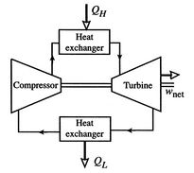
CONDITION OF MAXIMUM EFFICIECY:
$$η_{Carnot}=η_{Brayton}$$  $$1-\frac{1}{{\left(r_{P}\right)}^{\frac{γ-1}{γ}}}=1-\frac{T_{min}}{T_{max}}⇒{\left[r_{P}\right]}_{max}={\left(\frac{T_{max}}{T_{min}}\right)}^{\frac{γ}{γ-1}}$$  $$T_{max}=T_{3}, T_{min}=T_{1}$$ | NOTE: At ${\left[r_{P}\right]}_{max},$  $$T_{2}=T_{max}, T_{4}=T_{min} \& W_{net}=0$$  For maximum efficiency, $W_{net}=0$ because cycle becomes line. Hence, don’t design Brayton cycle for $η_{max}$  At $r_{P}={\left[r_{P}\right]}_{min}=1$, $η_{B}=W_{net}=0$ & Linear graph.
Hence, Gas Turbine are design for maximum work output. For simple Brayton Cycle,
$$W_{net}=W_{T}-W_{C}=C_{P}\left(T_{3}-T_{4}\right)-C_{P}\left(T_{2}-T_{1}\right)=C_{P}\left[T_{max}-\frac{T_{max}}{{\left(r_{P}\right)}^{\frac{γ-1}{γ}}}-T_{min}{\left(r_{P}\right)}^{\frac{γ-1}{γ}}+T_{min}\right]$$
For Maximum Work output,$$\frac{dW_{net}}{dr_{P}}=0⇒{\left[r_{P}\right]}_{opt}={\left(\frac{T_{max}}{T_{min}}\right)}^{\frac{γ}{2\left(γ-1\right)}}=\sqrt{{\left[r_{P}\right]}_{max}}$$ | At Maximum Work output,  $$T_{2}=T_{4}=\sqrt{T_{max}T_{min}}=\sqrt{T_{1}T_{3}}$$  $${\left[W_{net}\right]}_{max}=C_{P}{\left[\sqrt{T_{3}}-\sqrt{T_{1}}\right]}^{2}$$  $$η_{opt}=η @ {\left[r_{P}\right]}_{opt}=1-\sqrt{{T_{min}}/{T_{max}}}$$
BRAYTON CYCLE WITH MACHINE EFFICIENCIES:
1-2-3-4-1: Ideal Brayton Cycle & 1-2’-3-4’-1: Brayton Cycle With machine $η$  $$\frac{T_{2}}{T_{1}}={\left(\frac{P_{2}}{P_{1}}\right)}^{\frac{γ-1}{γ}}={\left(r_{P}\right)}^{\frac{γ-1}{γ}}=\frac{T_{3}}{T_{4}}={\left(\frac{P_{3}}{P_{4}}\right)}^{\frac{γ-1}{γ}}$$  $$η_{ise-C}=\frac{W_{rev}}{W_{act}}=\frac{h_{2}-h_{1}}{h_{2}^{'}-h_{1}}=\frac{T_{2}-T_{1}}{T_{2}^{'}-T_{1}}\left(∵\begin{matrix}Ideal Gas \\ dh=C_{P}dT\end{matrix}\right)$$  $$η_{ise-T}=\frac{W_{act}}{W_{rev}}=\frac{h_{3}-h_{4}^{'}}{h_{3}-h_{4}}=\frac{T_{3}-T_{4}^{'}}{T_{3}-T_{4}}\left(∵\begin{matrix}Ideal Gas \\ dh=C_{P}dT\end{matrix}\right)$$ |  |  | TS Diagram of Brayton Cycle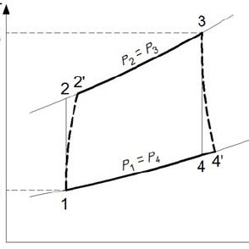
$$W_{C}=C_{P}\left(T_{2}^{'}-T_{1}\right)$$ | $$W_{T}=C_{P}\left(T_{3}-T_{4}^{'}\right)$$
$$q_{in}=C_{P}\left(T_{3}-T_{2}^{'}\right)$$ | $$q_{out}=C_{P}\left(T_{4}^{'}-T_{1}\right)$$
$$η=1-\frac{q_{out}}{q_{in}}=\frac{W_{net}}{q_{in}}$$ |  | $$Work Ratio=\frac{W_{net}}{W_{T}}$$
OPTIMUM PRESSURE RATIO FOR MAXIMUM WORK OUTPUT FOR BRAYTON CYCLE WITH MACHINE EFFICIENCY:
$$W_{net}=W_{T}-W_{C}=C_{P}\left(T_{3}-T_{4}^{'}\right)-C_{P}\left(T_{2}^{'}-T_{1}\right)=C_{P}\left[η_{T}\left(\frac{T_{3}}{{\left(r_{P}\right)}^{\frac{γ-1}{γ}}}-T_{3}\right)+\frac{T_{1}-T_{1}{\left(r_{P}\right)}^{\frac{γ-1}{γ}}}{η_{C}}\right]=f(r_{P})$$
For Maximum Work output,$$\frac{dW_{net}}{dr_{P}}=0⇒{\left[r_{P}\right]}_{opt}={\left[η_{T}η_{C}\frac{T_{3}}{T_{1}}\right]}^{\frac{γ}{2\left(γ-1\right)}}$$  In actual cycle, there is pressure drop in the cycle due to irreversibility’s present in the system. | 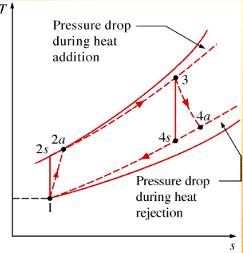
ANALYSIS OF COMBUSTION CHAMBER:
- OPEN SYSTEM COMBUSTION CHAMBER:
From Energy Balance, $m_{a}C_{Pa}T_{2}+m_{f} CV η_{Combustion}=\left(m_{a}+m_{f}\right)C_{Pe}T_{3}$  $$\left(AFR\right)C_{Pa}T_{2}+CV η_{Combustion}=\left(1+AFR\right)C_{Pe}T_{3}$$ | $$m_{f}$$  $$m_{a}$$ CC $$m_{a}+m_{f}$$

- CLOSED SYSTEM COMBUSTION CHAMBER:
From Energy Balance, $m_{a}C_{Pa}T_{2}+m_{f} CV η_{Combustion}=m_{a}C_{Pa}T_{3}$  $$\left(AFR\right)C_{Pa}T_{2}+CV η_{Combustion}=\left(AFR\right)C_{Pa}T_{3}$$ | CC ($m_{f},CC,η_{Combustion}$)  $$m_{a}$$ HE $$m_{a}$$
Note: If $C_{Pe}$ is not given in the question, then the system is closed.
FREE SHAFT TURBINE: Power output Shaft of turbine and compressor shaft is not connected due to requirement of the power in the compressor at different RPM. So as to compensate this issue HPT & LPT are used.
$$f=\frac{PN}{120}$$  $P=$ No. of Poles $N=$Speed of shaft (RPM)  $f=$ Frequency of the current  $$r_{P}=\frac{P_{2}}{P_{1}}=\frac{P_{3}}{P_{5}}={\left[r_{P}\right]}_{HPT}{\left[r_{P}\right]}_{LPT}$$  $$W_{HPT}=W_{C}⇒T_{3}-T_{4}=T_{2}-T_{1}$$  $$q_{in}=C_{P}\left(T_{3}-T_{2}\right)$$  $$W_{net}=W_{load}=W_{LPT}=C_{P}\left(T_{4}-T_{5}\right)$$  $$η=1-\frac{q_{out}}{q_{in}}=\frac{W_{net}}{q_{in}}=\frac{T_{4}-T_{5}}{T_{3}-T_{2}}$$ | 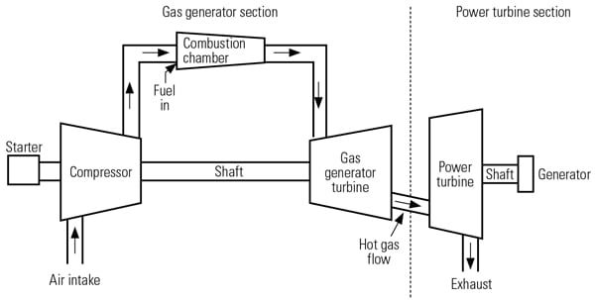T-S Diagram will remain the same only Exp. Point is shown.
WHY CARNOT CYCLE EFFICIENCY IS MAXIMUM?
$$η_{rev.}=1-\frac{Mean Temp. of Heat Rejection}{Mean Temp. of Heat Addition}$$ | For Carnot Cycle, $T_{mA}=T_{max} \& T_{mR}=T_{min}$  For any other cycle, $T_{mA}<T_{max} \& T_{mR}>T_{min}$
$$Q_{in}=T_{mA}\left(S_{3}-S_{2}\right)$$ | Hence, Mean Temp can be found using this Area equivalency.
REGENERATION IN BRAYTON CYCLE: Method of recovery of heat of exhaust gases.
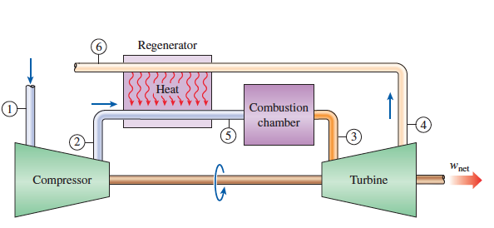 | 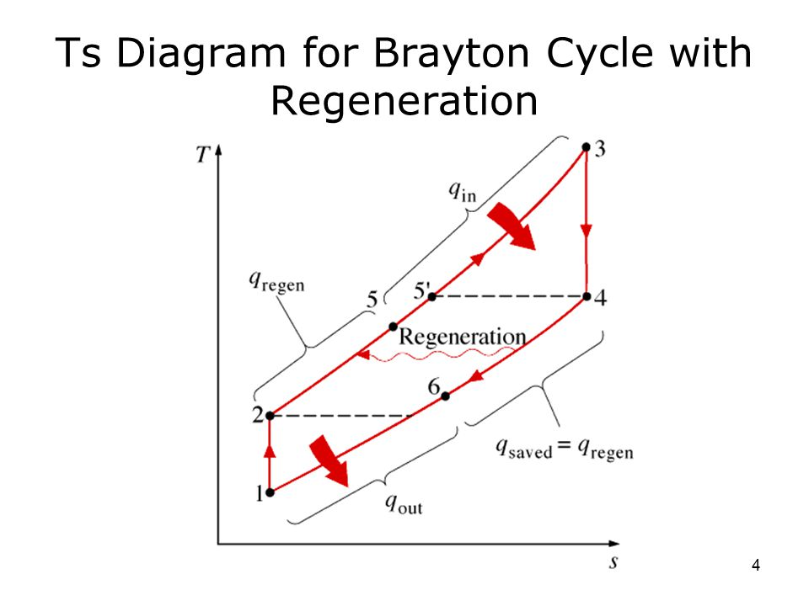
Energy balance in regenerator, $h_{4}-h_{6}=h_{5}-h_{2}⇒T_{4}-T_{6}=T_{5}-T_{2}(∵For ideal Gas dh=C_{P}dT)$
It is basically heat recovery of exhaust gases. Exhaust gases is used to preheat the compressed air. Heat input required for combustion chamber decreases. No change in turbine & compressor work. Hence, efficiency of the cycle increases because mean temperature of heat addition increases.
EFFECTIVENESS OF REGENERATION:
$$e=\frac{{\left(∆T\right)}_{act}}{{\left(∆T\right)}_{max}}=\frac{T_{5}-T_{2}}{T_{4}-T_{2}}$$ | For ideal Regenerator, $e=1⇒T_{5}=T_{4}$  From 1st law, $T_{4}-T_{6}=T_{5}-T_{2}⇒T_{6}=T_{2}$
EFFICIENCY OF IDEAL REGENERATIVE CYCLE:
$$q_{in}=C_{P}\left(T_{4}-T_{3}\right)$$ | $$q_{out}=C_{P}\left(T_{6}-T_{1}\right)$$ |  | 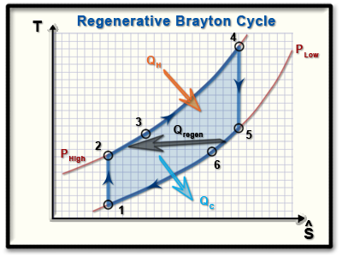
For ideal regenerative cycle,  $$T_{6}=T_{4} \& T_{3}=T_{5}$$ | $$r_{P}=\frac{P_{2}}{P_{1}}=\frac{P_{4}}{P_{5}}$$
$$\frac{T_{2}}{T_{1}}={\left(\frac{P_{2}}{P_{1}}\right)}^{\frac{γ-1}{γ}}={\left(r_{P}\right)}^{\frac{γ-1}{γ}}=\frac{T_{4}}{T_{5}}={\left(\frac{P_{4}}{P_{5}}\right)}^{\frac{γ-1}{γ}}$$
$$η=1-\frac{T_{2}-T_{1}}{T_{4}-T_{5}}=1-\frac{T_{1}}{T_{5}}=1-\frac{T_{min}}{T_{max}}{\left(r_{P}\right)}^{\frac{γ-1}{γ}}$$
For ${\left[r_{P}\right]}_{min}=1$, $η_{Carnot}=η_{IdealReg.Brayton}$ |  | For ${\left[r_{P}\right]}_{max}={\left({T_{max}}/{T_{min}}\right)}^{\frac{γ}{\left(γ-1\right)}}, η_{IdealReg.Brayton}=0$
If $η_{IR}=η_{SBC}$  $${\left[r_{P}\right]}_{cr}={\left[r_{P}\right]}_{opt}={\left(\frac{T_{max}}{T_{min}}\right)}^{\frac{γ}{2\left(γ-1\right)}}$$  CASE Result Regeneration  $${\left[r_{P}\right]}_{act}<{\left[r_{P}\right]}_{opt}$$ $$η_{IR}>η_{SBC}$$ Possible  $${\left[r_{P}\right]}_{act}={\left[r_{P}\right]}_{opt}$$ $$η_{IR}=η_{SBC}$$ No need  $${\left[r_{P}\right]}_{act}>{\left[r_{P}\right]}_{opt}$$ $$η_{IR}<η_{SBC}$$ Don’t use Not Practical |  | 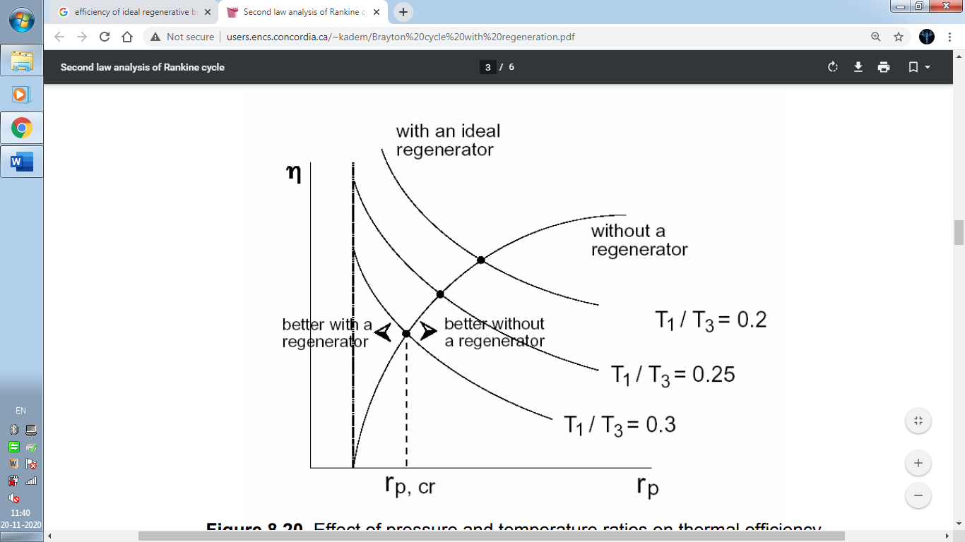
REHEATING IN BRAYTON CYCLE:
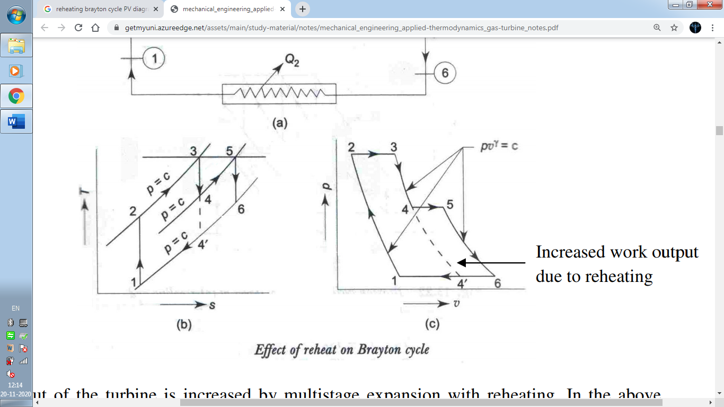 |  |  | 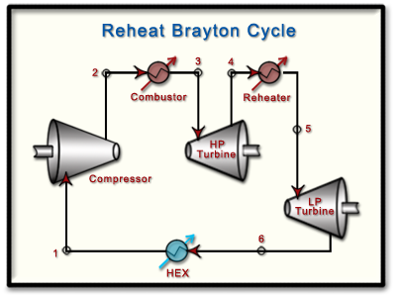
Here, $T_{3}=T_{5}=T_{max}$ & $T_{1}=T_{min}$  & $P_{4}=P_{5}=P_{int}$ | $$r_{P}=\frac{P_{2}}{P_{1}}=\frac{P_{3}}{P_{6}}={\left(r_{P}\right)}_{HPT}{\left(r_{P}\right)}_{LPT}$$ |  | $$W_{T}=\left(h_{3}-h_{4}\right)+\left(h_{5}-h_{6}\right)$$  $$=C_{P}\left(T_{3}-T_{4}\right)+C_{P}\left(T_{5}-T_{6}\right)$$  $$W_{C}=h_{2}-h_{1}=C_{P}\left(T_{2}-T_{1}\right)$$  $$q_{in}=\left(h_{3}-h_{2}\right)+\left(h_{5}-h_{4}\right)$$  $$=C_{P}\left(T_{3}-T_{2}\right)+C_{P}\left(T_{5}-T_{4}\right)$$  $$q_{out}=h_{6}-h_{1}=C_{P}\left(T_{6}-T_{1}\right)$$  $$W_{net}=W_{T}-W_{C}$$  $$η={W_{net}}/{q_{in}}$$
$$\frac{T_{2}}{T_{1}}={\left(\frac{P_{2}}{P_{1}}\right)}^{\frac{γ-1}{γ}}={\left(r_{P}\right)}^{\frac{γ-1}{γ}}$$ | For Max Work Output,  $$\frac{dW_{net}}{dP_{int}}=0⇒{\left[P_{int}\right]}_{opt}=\sqrt{P_{1}P_{2}}$$
$$W_{net}=C_{P}T_{3}\left[2-{\left(\frac{P_{int}}{P_{2}}\right)}^{\frac{γ-1}{γ}}-{\left(\frac{P_{1}}{P_{int}}\right)}^{\frac{γ-1}{γ}}\right]=f(P_{int})$$
$$\frac{T_{3}}{T_{4}}={\left(\frac{P_{3}}{P_{4}}\right)}^{\frac{γ-1}{γ}}={\left(\frac{P_{2}}{P_{int}}\right)}^{\frac{γ-1}{γ}}={\left(r_{P}\right)}_{LPT}^{\frac{γ-1}{γ}}$$ |  | $$\frac{T_{6}}{T_{5}}={\left(\frac{P_{6}}{P_{5}}\right)}^{\frac{γ-1}{γ}}={\left(\frac{P_{1}}{P_{int}}\right)}^{\frac{γ-1}{γ}}={\left(r_{P}\right)}_{LPT}^{\frac{γ-1}{γ}}$$
COMPARISON OF REHEAT CYCLE WITH SBC:
$${\left[W_{T}\right]}_{RHC}>{\left[W_{T}\right]}_{SBC}$$  $${\left[W_{C}\right]}_{RHC}={\left[W_{C}\right]}_{SBC}$$ | $${\left[W_{net}\right]}_{RHC}>{\left[W_{net}\right]}_{SBC}$$  $${\left[q_{in}\right]}_{RHC}>{\left[q_{in}\right]}_{SBC}$$
Cannot say anything about $η_{RHC} \& η_{SBC}$. But Practically always $η_{RHC}< η_{SBC}$. So, to increase the efficiency of the cycle Regeneration is provided with reheating gives maximum efficiency Because of increase in temperature difference. ${\left[∆T\right]}_{RHC}>{\left[∆T\right]}_{SBC}$ Where, ${\left[∆T\right]}_{SBC}=T_{2}-T_{4}^{'} \& {\left[∆T\right]}_{RHC}=T_{3}-T_{4}$
INTERCOOLING IN BRAYTON CYCLE:
- It’s basically used to reduce the compression work.
- In intercooling compression is done in two or more stages.
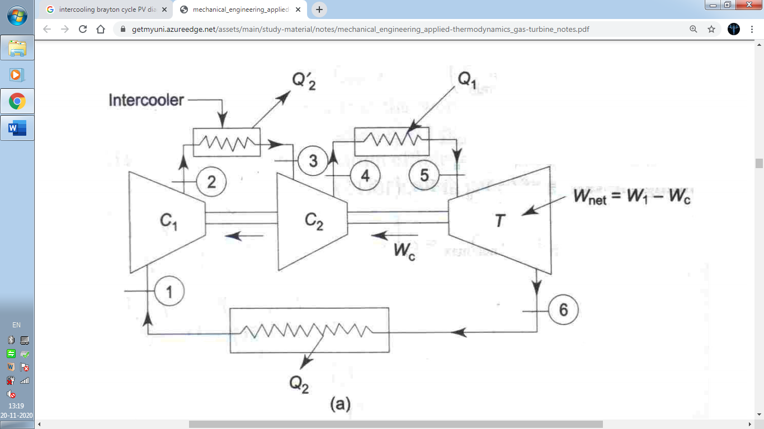 |  |  | 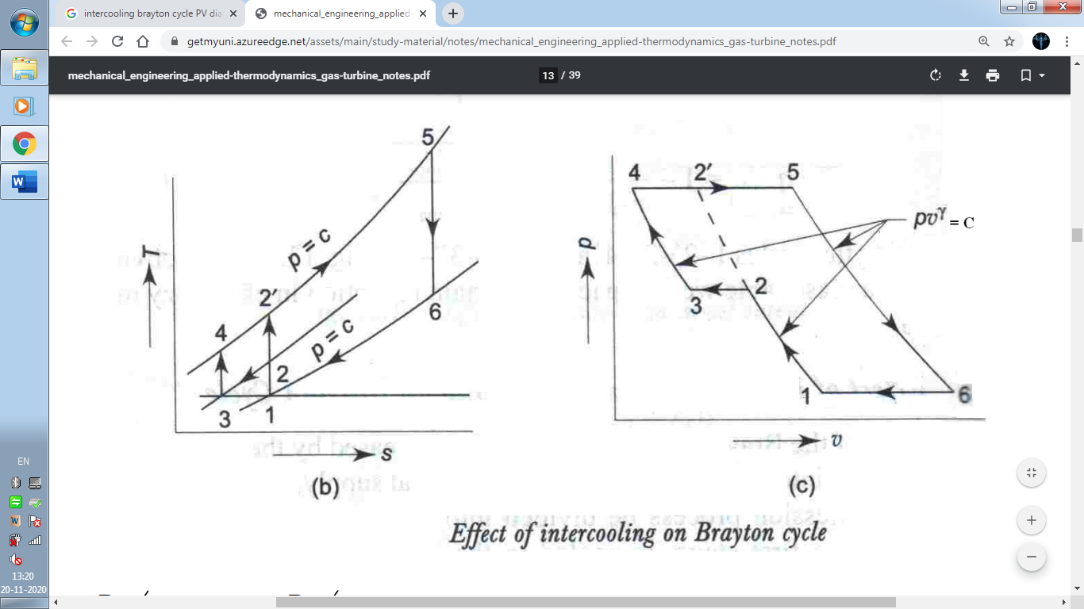
$$W_{C}=W_{C1}+W_{C2}=\left(h_{2}-h_{1}\right)+\left(h_{4}-h_{3}\right)=C_{P}\left(T_{2}-T_{1}\right)+C_{P}\left(T_{4}-T_{3}\right)<W_{c}^{'}(SBC Comp. Work=h_{2}^{'}-h_{1})$$
$$W_{T}=\left(h_{5}-h_{6}\right)=C_{P}\left(T_{5}-T_{6}\right)$$ | $$q_{in}=\left(h_{5}-h_{4}\right)=C_{P}\left(T_{5}-T_{4}\right)$$ |  |  |  | For ideal intercooler,$T_{3}=T_{1}$
$${\left[P_{int}\right]}_{opt}=\sqrt{P_{1}P_{2}}$$ |  | $$W_{net}=W_{T}-W_{C}$$ |  | $$η={W_{net}}/{q_{in}}$$
COMPARISON OF INTERCOOLING WITH SBC:
- There may be little gain in efficiency due to intercooling but in most of the cases it decreases.
- Due to intercooling scope of regeneration increases.
- Intercooling along with regeneration increases efficiency.
- Intercooling is effective at high pressure ratio.
$${\left[W_{T}\right]}_{IC}={\left[W_{T}\right]}_{SBC}$$  $${\left[W_{C}\right]}_{IC}<{\left[W_{C}\right]}_{SBC}(From area proj. on P axis of Cyc.)$$ | $${\left[W_{net}\right]}_{IC}>{\left[W_{net}\right]}_{SBC}$$  $${\left[q_{in}\right]}_{IC}>{\left[q_{in}\right]}_{SBC}$$
- Cannot say anything about $η_{IC} \& η_{SBC}$. But Practically always $η_{IC}< η_{SBC}$. So, to increase the efficiency of the cycle Regeneration is provided with intercooling gives maximum efficiency Because of increase in temperature difference. ${\left[∆T\right]}_{IC}>{\left[∆T\right]}_{SBC}$ Where, ${\left[∆T\right]}_{SBC}=T_{6}-T_{2}^{'} \& {\left[∆T\right]}_{IC}=T_{6}-T_{4}$
- Intercooling is useful at high pressure ratio. (Multiple compression system)
By using Regeneration, Intercooling & Reheating Efficiency of the cycle can be increase.
BRAYTON CYCLE WITH MANY NO. OF INTERCOOLER, REHEATER & IDEAL REGENERATOR:
When many numbers of intercoolers and compressors are used, the isentropic compression process converts into isothermal process with heat rejection. And When many numbers of reheaters are used, the isentropic expansion process converts into isothermal process with heat addition. This conversion in the Brayton cycle is called Ericsson Cycle.  Here, $T_{4}=T_{3}$ & $T_{1}=T_{2}$ |  | 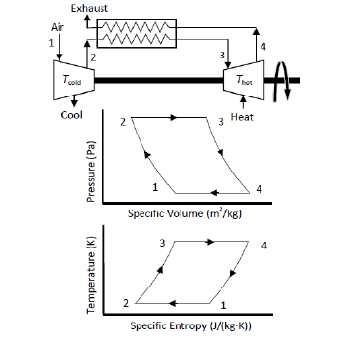
$$q_{in}=\left(h_{3}-h_{2}\right)=C_{P}\left(T_{3}-T_{2}\right)$$ | $$q_{out}=\left(h_{4}-h_{1}\right)=C_{P}\left(T_{4}-T_{1}\right)$$
Hence, $q_{in}=q_{out}$
Efficiency of the ideal Ericsson cycle with ideal regenerator is equal to Carnot cycle. But actually, ideal regenerator is not possible.
$$η_{Carnot}=η_{Ericsson}$$
STIRLING CYCLE:
It’s came as Ericsson Cycle only Constant pressure processes are replaced by constant volume process.  For ideal regenerator,  $$η_{Stirling}=η_{Ericsson}=η_{Carnot}$$ | 